Catalog
Chapter 1 Overview ........ .. .............. ......... 1
1.1 Brief introduction. ................................ 1
1.2 Test principle. .................................... 1
1.3 Instruments ..... ..... ..... ..... ..... ..... .....2
1.4 Performance of instruments ..........................3
1.5 Precautions
Chapter 2 Operation of Instrument......................4
2.1 Opening ...........................................4
2.2 Functional selection interface ....... ....... .......5
2.3 Resistivity test.................................... 5
2.4 Data view............................... ........... 9
2.5 Data transmission..................................10
2.6 Data deleting...................................... 11
2.7 Date setting...................................... 12
2.8 Pow-off.... ...................................... 12
Appendix: resistivity reference standard ...............13

Chapter 1 Overview
  - brief introduction
The R62 concrete resistivity tester is also called the potential tester (corrosion analyzer). The corrosion of the steel in the concrete is an electrochemical process. It produces the current to dissociate the metal. The lower the resistivity, the more easy the corrosion current flows through the concrete, the greater the possibility of corrosion, and the resistivity of the concrete can be effectively measured. The corrosion resistance is evaluated and the corrosion degree of existing steel bars is evaluated.

  - Test principle
Semi-battery method No need to destroy the steel bar on the surface of reinforced concrete for orientation corrosion. By using this method, contour map drawing program can effectively locate the area of rust activity. When connecting bars and cables, part of the concrete surface needs to be destroyed.However, the use of R62 concrete resistivity tester WennerProbe contact concrete protection layer,It can easily measure the corrosion status of concrete protective layer. The resistivity of concrete plays an important role in detecting rust. When the resistivity of concrete is low, the possibility of its rust activity is much higher than that of high resistivity.The resistivity is calculated by formula R=V/I and Rho =2 PI alpha R, in which R is a resistance, V is the measured voltage through the electrode, I is the current flowing through the electrode, the coefficient of resistance is the resistance coefficient, and the alpha is the distance between the electrodes.

$R=V/I,ρ=2\text{πα}R$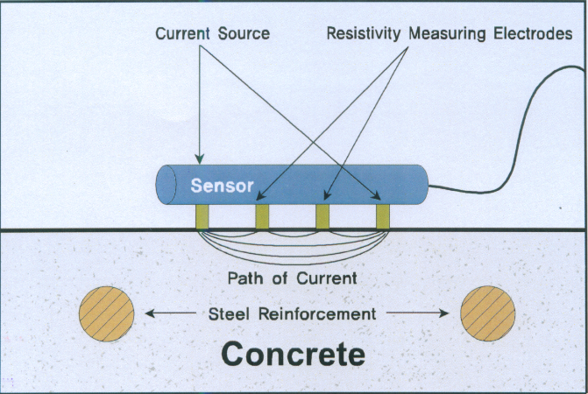
R62 includes a row of four electrodes. By measuring the outside two electrodes through the current, the voltage generated on the two internal electrodes can be measured. R62 can evaluate the corrosion of the concrete and display the resistivity (K Omega /cm) on the host.
  - Composition of instruments
The instrument consists of main engine, probe, signal wire, USB transmission line, data bag, battery, aluminum alloy box, etc. (as shown in Figure 1-2).
Host | Probe | The signal line | USB line
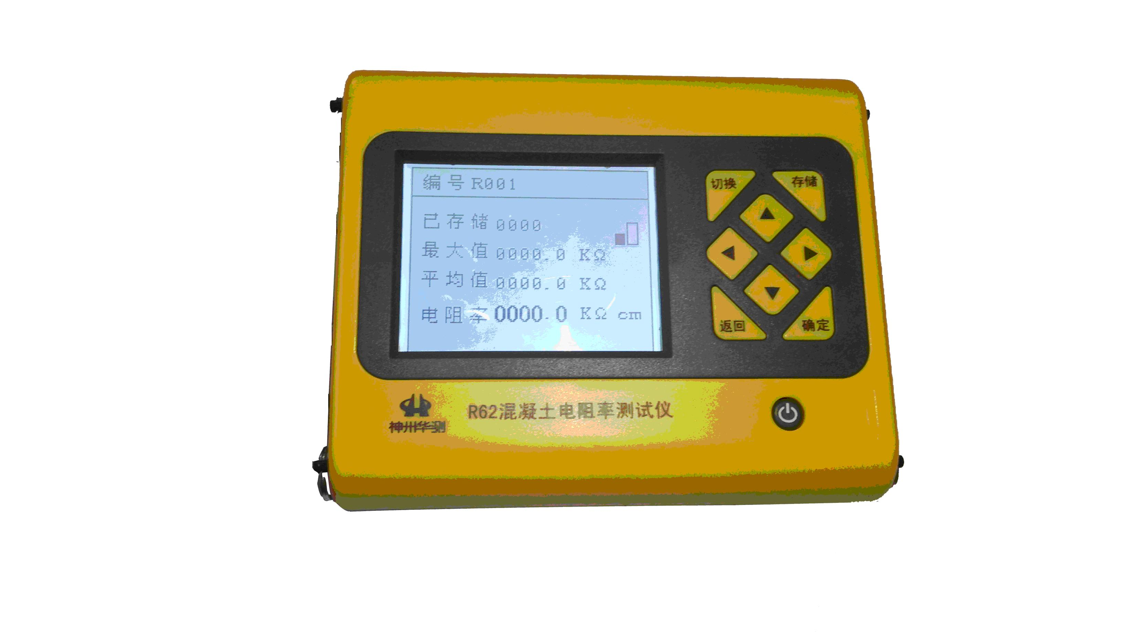 | 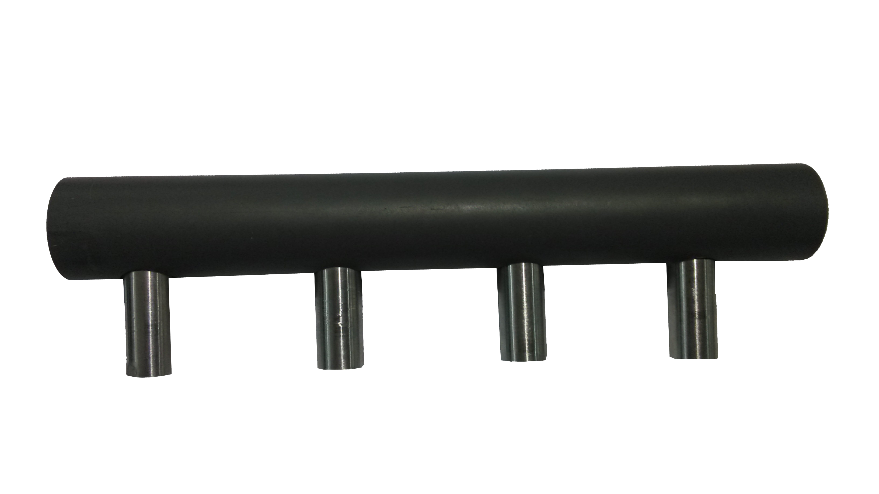 | 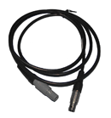 | 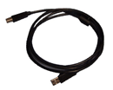
Information bag | Battery | Box
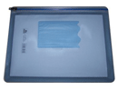 | 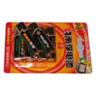 | 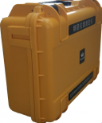

Figure 1-2
1.4 Performance of instruments
1. The measurement range is:0~300 kΩcm;0~3000 kΩcm;
2. The measurement accuracy is:±1 kΩcm;
3. Resolution:0.1kΩcm；
4. liquid crystal display:160*128;
5. The built-in lithium battery;

1.5 Attention
1. R62 is easily influenced by ambient temperature and water content of concrete.
2. Because the current will be affected by the reinforcement in the concrete, so the probe should be far away from the reinforcement.
3. When the width of the concrete surface is narrower than the width of the probe, or if all the four electrodes fail to touch too rough concrete surface, the measurement cannot be carried out.
4. Without permission, do not open the instrument case, otherwise the consequences will be conceited.
Chapter 2 Operation of Instrument
The key description of the instrument is Table 2.1
Key | Functional description
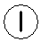  key | The switch of the power supply of the instrument
OK | Confirm an operation or start testing when testing the interface
Save | Used to store detection values
Esc | For operation, return to the previous screen or cancel function in function selection.
↑ ↓  ← → | They are used for menu selection, digital addition and subtraction, cursor movement and other auxiliary functions←It can also be used to open or close the background light
Table 2.1 key instructions
2.1 Opening
Press the instrument panelKey,The instrument works on
electricity and starts working. The starting interface is
shown in Figure 2-1.
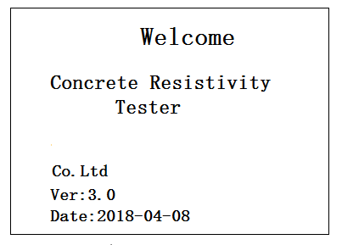

Figure 2-1 opening interface

2.2 Functional selection interface
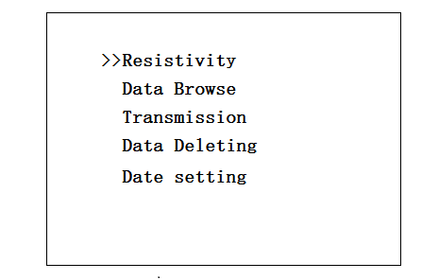
Press any key at the start interface(←The button can turn on the backlight at this time),Enter the function selection interface, as shown in Figure 2-2.

Figure 2-2 functional selection interface
The function selection interface has the functions of electrical resistivity testing, data viewing, data deletion, data transmission and date setting.adopt↑、↑Key,Select the corresponding function,PressOKThe key enters the corresponding functional interface.
2.3 Resistivity test
The resistivity test interface is shown in Figure 2-3. The interface of resistivity test is divided into two parts: information area and test area.
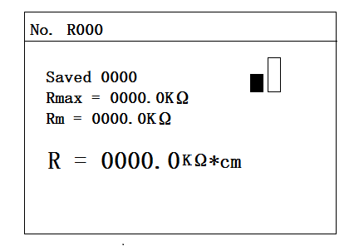

Figure 2-3 resistivity testing interface
In the information area, users can set numbers. The instrument can automatically switch between low and high ranges according to the resistivity. When the test type is selected for a low range, the icon is shown in Figure 2-4, and the icon is shown in Figure 2-5 when the test range is high.

Figure 2-4 low range display
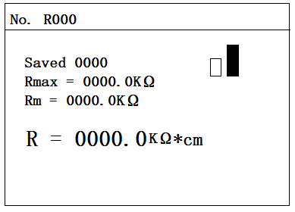

Figure 2-5 high range display
The resistivity testing process is shown in Figure 2-6.
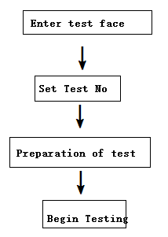
Figure 2-6 test flow
2.3.1 Setting number
Setting the engineering number of the resistivity test.
Project number: number for each project.
Operation: press←、→ Key move the cursor position, press ↑、↓The key can adjust the numeric value of the cursor position.PressOKKey confirm setting and testing,pressEsc The key returns to the upper interface,If the test area does not changeThe OKkey is the subsequent measurement of the data in the original component.
2.3.2 Preparation of test
- Put the sponge into the sensor probe
The purpose of the sponge into the sensor probe.In order to get the accurate result, sponge of sensor should be kept clean. Baths (water containers) should be cleaned before and after testing. The sponge is immersed in water, and then it is stuffed into four holes of the container. After use, remove the sponge and wash it with tap water. The sponge should be cleaned regularly with a bathtub (water container).
- Connect the sensor to instrument
To connect the sensor and instrument through the cable,
it is suggested that the instrument should not be opened before the connection, and then the instrument is reopened after the connection, otherwise the instrument may be damaged.
- The concrete surface
If the concrete surface is too dry or too wet, it may cause great error. When the surface of concrete is dirty, it cannot be measured, which may lead to great errors. Therefore, as far as possible, keep the surface condition of the concrete well. If the surface of the concrete is coated with paint, it will not be able to measure the electrical resistivity. Similarly, if the concrete surface is coated with waterborne coatings, the measurement will not be correct. Under these circumstances, we should drill holes in 2~3mm on the concrete surface and measure them in the concrete so as to get the best results.
- The host
R62 consumes electricity very much, so it is better to charge the instrument before measuring.
Before the field measurement, turn on the instrument and check whether the instrument is working normally. Use a reference block to check whether the results are normal.
Because there is no predefined minimum clearance for concrete surface measurement, the measurement at the same point is of little significance. If the measuring gap is too large, it is possible to neither detect the current corrosion activity nor generate the wrong data accumulation. Therefore, the measurement gap should be consistent with the measured concrete and the final measured results. In general, the field measurement gap is 50cm. If the possibility of corrosion is high, we recommend smaller clearances. When measuring in a specific place, it is best to keep the sensor as far away from the reinforcement as possible.
2.3.3 Resistivity test
After the completion of the test, you can start the test. First, we introduce the current parameter area of the test area, which is as follows:
It has storage: stored data number;
The purpose of maximum: maximum value in acquisition data;
An average value of average value in acquisition data;
Purpose: resistivity resistivity values;
In the testing process are as follows
1.PressOK The key enters the test interface.
2.When the sensor is placed on the measuring area, the measured resistivity value is displayed on the LCD screen, and the resistivity value is stable pressingSave Key,That is to complete the test.
3. during the measurement process, the switch key changes the high and low range. After changing, it displays the current resistivity value on the LCD screen.
4.After the measurement is completed, the next measurement area is continuously measured.PressEsc Key,You can reset the parameters.
2.4 Dataview
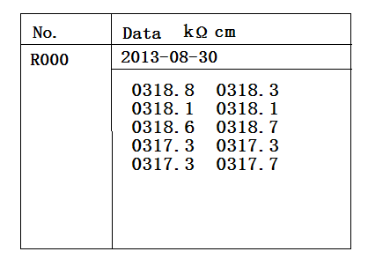
The data view interface (as shown in Figure 2-10), the left side is the layout area, and the right side is the data area.Press↑、↓Keys can choose different numbering values, and the right data area displays the date and resistivity value of the currently selected numbers.Press the Esc key to return the function selection interface.

Figure 2-7 data view interface
2.5 Data transmission
The USB transmission interface is shown in Figure 2-8.Press OK key is transmitted,PressEsc Key return function selection interface. During transmission, prompt transmission. As shown in Figure 2-9, after the end of the transmission, the prompt ends the transmission, as shown in Figure 2-10, and then press any key to return to the function to select the interface.

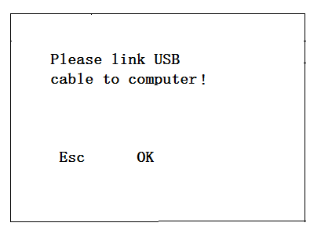

Figure 2-8 USB transmission interface
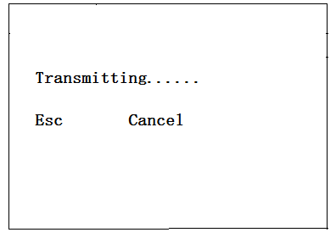
Figure 2-9 USB transmission interface
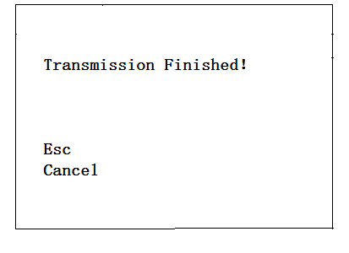
Figure 2-10 End interface
2.6 Data deleting
The data deleting interface is shown in Figure 2-11.Press OKKey delete all data, and delete after data deletion.Press Esc key The data is not deleted to return to the functional selection interface.
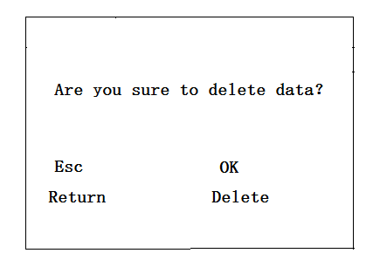
Figure 2-11 Data deleting interface
Note: all data can't be recovered after being deleted. Please use this function with caution.
2.7 Date setting
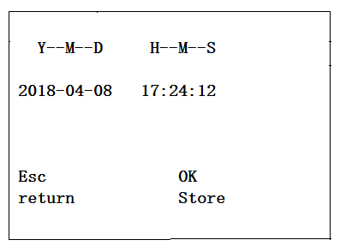
The date setting interface is like figure 2-12.

Figure 2-12 Date setting
Press←、→The key moves the cursor position,Press↑、↓The key modifies the value,Revise and pressEsc The key does not save the settings to return,PressSave Key save settings return.
2.8 Power-off
PressKey can be shut down.
Appendix: reference standard for resistivity
Schedule
Serial number | resistivity | Corrosion possibility
1 | ≤5 kΩcm | Very high
2 | 5～10 kΩcm | high
3 | 10～20 kΩcm | secondary
4 | 20～199.9 kΩcm | Good / corrosive
5 | 〉200kΩcm | Good / corrosion probability is minimal

